**Design and implement a robust, distributed system using C++ that effectively leverages signals, sockets, and inter-process communication (IPC) to manage and coordinate multiple processes for a real-time data processing pipeline.**

**System Requirements**

**Data Ingestion: Continuously receive data from multiple sources (e.g., network sockets, files, sensors) and distribute it across multiple worker processes.**

**Data Processing: Distribute incoming data to multiple worker processes, each responsible for specific data transformations or calculations.**

**Error Handling: Implement robust error handling mechanisms using signals to gracefully handle unexpected events (e.g., process termination, network failures).**

**Inter-Process Communication: Utilize IPC (e.g., shared memory, message queues) for efficient communication and synchronization between processes.**

**Performance Optimization: Optimize the system for low latency and high throughput, considering factors like network congestion, process scheduling, and data transfer efficiency.**

**Scalability: Design the system to handle increasing data volumes and processing load by dynamically adjusting the number of worker processes**

**Server:**

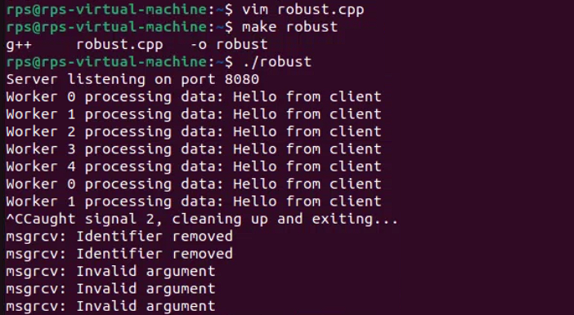

#include <iostream>

#include <unistd.h>

#include <sys/types.h>

#include <sys/ipc.h>

#include <sys/shm.h>

#include <sys/msg.h>

#include <sys/socket.h>

#include <netinet/in.h>

#include <arpa/inet.h>

#include <cstring>

#include <csignal>

#include <vector>

#include <thread>

#define PORT 8080

#define BUFFER_SIZE 4096

#define SHM_KEY 1234

#define MSG_KEY 5678

#define MAX_WORKERS 5

struct message {

long mtype;

int data_length;

};

int shm_id, msg_id;

void handle_signal(int sig) {

std::cout << "Caught signal " << sig << ", cleaning up and exiting..." << std::endl;

shmctl(shm_id, IPC_RMID, nullptr);

msgctl(msg_id, IPC_RMID, nullptr);

exit(0);

}

void setup_signal_handler() {

struct sigaction sa;

sa.sa_handler = handle_signal;

sigemptyset(&sa.sa_mask);

sa.sa_flags = 0;

sigaction(SIGINT, &sa, nullptr);

sigaction(SIGTERM, &sa, nullptr);

}

void data_ingestion_server() {

int server_fd, new_socket;

struct sockaddr_in address;

int opt = 1;

int addrlen = sizeof(address);

char buffer[BUFFER_SIZE] = {0};

if ((server_fd = socket(AF_INET, SOCK_STREAM, 0)) == 0) {

perror("socket failed");

exit(EXIT_FAILURE);

}

if (setsockopt(server_fd, SOL_SOCKET, SO_REUSEADDR | SO_REUSEPORT, &opt, sizeof(opt))) {

perror("setsockopt");

close(server_fd);

exit(EXIT_FAILURE);

}

address.sin_family = AF_INET;

address.sin_addr.s_addr = INADDR_ANY;

address.sin_port = htons(PORT);

if (bind(server_fd, (struct sockaddr *)&address, sizeof(address)) < 0) {

perror("bind failed");

close(server_fd);

exit(EXIT_FAILURE);

}

if (listen(server_fd, 3) < 0) {

perror("listen");

close(server_fd);

exit(EXIT_FAILURE);

}

std::cout << "Server listening on port " << PORT << std::endl;

while ((new_socket = accept(server_fd, (struct sockaddr )&address, (socklen_t)&addrlen)) >= 0) {

ssize_t bytes_read = read(new_socket, buffer, BUFFER_SIZE);

if (bytes_read > 0) {

void* shm_ptr = shmat(shm_id, nullptr, 0);

if (shm_ptr == (void*)-1) {

perror("shmat");

close(new_socket);

continue;

}

memcpy(shm_ptr, buffer, bytes_read);

struct message msg;

msg.mtype = 1;

msg.data_length = bytes_read;

if (msgsnd(msg_id, &msg, sizeof(msg.data_length), 0) == -1) {

perror("msgsnd");

}

shmdt(shm_ptr);

}

close(new_socket);

}

if (new_socket < 0) {

perror("accept");

}

}

void worker_process(int worker_id) {

while (true) {

struct message msg;

if (msgrcv(msg_id, &msg, sizeof(msg.data_length), 1, 0) == -1) {

perror("msgrcv");

continue;

}

void* shm_ptr = shmat(shm_id, nullptr, 0);

if (shm_ptr == (void*)-1) {

perror("shmat");

continue;

}

std::string data(static_cast<char*>(shm_ptr), msg.data_length);

std::cout << "Worker " << worker_id << " processing data: " << data << std::endl;

shmdt(shm_ptr);

}

}

int main() {

setup_signal_handler();

shm_id = shmget(SHM_KEY, BUFFER_SIZE, IPC_CREAT | 0666);

if (shm_id == -1) {

perror("shmget");

exit(EXIT_FAILURE);

}

msg_id = msgget(MSG_KEY, IPC_CREAT | 0666);

if (msg_id == -1) {

perror("msgget");

shmctl(shm_id, IPC_RMID, nullptr);

exit(EXIT_FAILURE);

}

std::vector<std::thread> workers;

for (int i = 0; i < MAX_WORKERS; ++i) {

workers.emplace_back(worker_process, i);

}

data_ingestion_server();

for (auto& worker : workers) {

worker.join();

}

shmctl(shm_id, IPC_RMID, nullptr);

msgctl(msg_id, IPC_RMID, nullptr);

return 0;

}

**Client:**

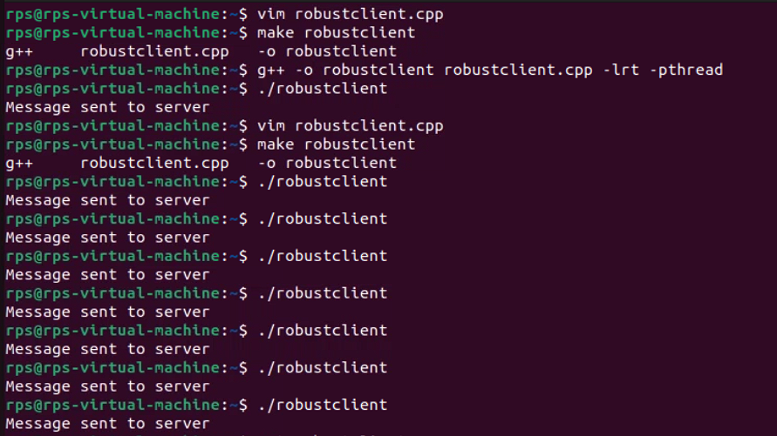

#include <iostream>

#include <sys/socket.h>

#include <arpa/inet.h>

#include <unistd.h>

#include <cstring>

#define PORT 8080

#define BUFFER_SIZE 4096

int main() {

int sock = 0;

struct sockaddr_in serv_addr;

char buffer[BUFFER_SIZE] = "Hello from client";

// Create socket

if ((sock = socket(AF_INET, SOCK_STREAM, 0)) < 0) {

std::cerr << "Socket creation error" << std::endl;

return -1;

}

serv_addr.sin_family = AF_INET;

serv_addr.sin_port = htons(PORT);

// Convert IPv4 and IPv6 addresses from text to binary form

if (inet_pton(AF_INET, "127.0.0.1", &serv_addr.sin_addr) <= 0) {

std::cerr << "Invalid address/ Address not supported" << std::endl;

return -1;

}

// Connect to the server

if (connect(sock, (struct sockaddr *)&serv_addr, sizeof(serv_addr)) < 0) {

std::cerr << "Connection Failed" << std::endl;

return -1;

}

// Send data to the server

send(sock, buffer, strlen(buffer), 0);

std::cout << "Message sent to server" << std::endl;

// Close the socket

close(sock);

return 0;

}

**Coding Questions in C++**

**Signal Handling:**

**Write a C++ program that sets up a signal handler for SIGINT. The program should perform some tasks and print a message when SIGINT is caught, then terminate gracefully.**

**SIGINT:**

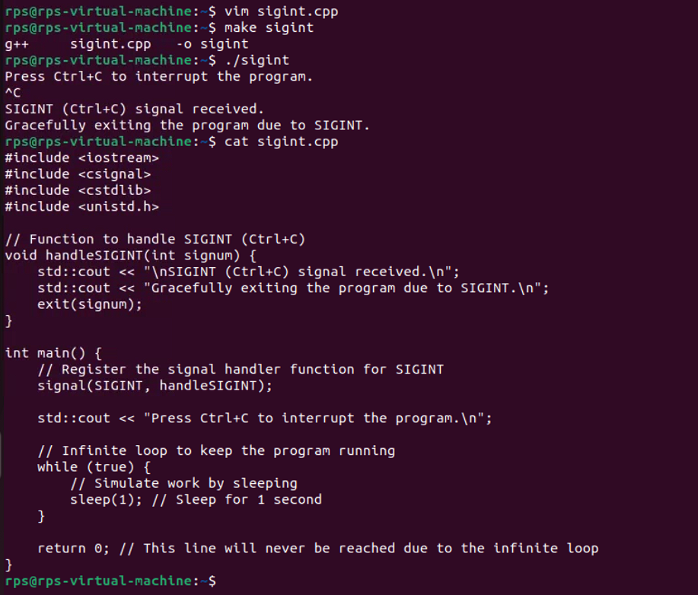

**How would you modify your program to handle multiple different signals, each with a unique handling function?**

**Multiple Signals:**

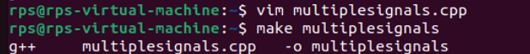

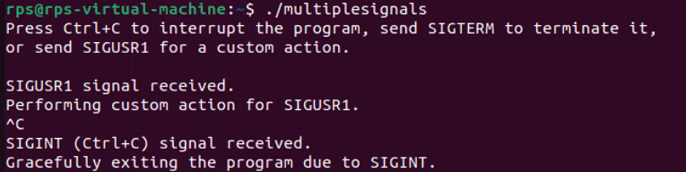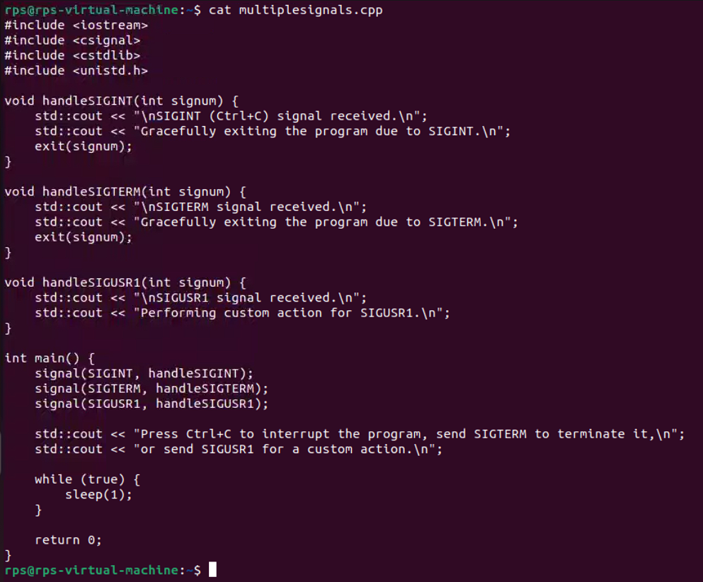

**Sockets for Network Communication:**

**Implement a simple echo server in C++ that listens on a specific port, accepts client connections, and echoes back any messages received from clients.**

**Write a client program that connects to the echo server, sends a message, and prints the echoed response.**

**SERVER**

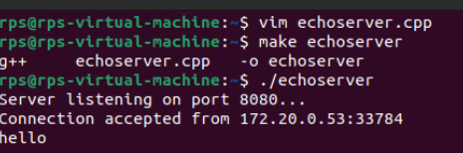

#include <iostream>

#include <cstring>

#include <unistd.h>

#include <arpa/inet.h>

#include <sys/socket.h>

using namespace std;

constexpr int PORT = 8080;

constexpr int BACKLOG = 5;

constexpr int BUFFER_SIZE = 1024;

void handle_client(int client_socket) {

char buffer[BUFFER_SIZE];

int bytes_received;

while ((bytes_received = recv(client_socket, buffer, BUFFER_SIZE, 0)) > 0) {

buffer[bytes_received] = '\0'; // Null-terminate the received data

cout << "Received: " << buffer;

// Echo back the message

send(client_socket, buffer, bytes_received, 0);

}

close(client_socket);

}

int main() {

int server_socket, client_socket;

struct sockaddr_in server_addr, client_addr;

socklen_t addr_size = sizeof(struct sockaddr_in);

// Create socket

server_socket = socket(AF_INET, SOCK_STREAM, 0);

if (server_socket == -1) {

cerr << "Error creating socket\n";

return 1;

}

// Prepare the sockaddr_in structure

server_addr.sin_family = AF_INET;

server_addr.sin_addr.s_addr = INADDR_ANY;

server_addr.sin_port = htons(PORT);

// Bind

if (bind(server_socket, (struct sockaddr *) &server_addr, sizeof(server_addr)) < 0) {

cerr << "Bind failed\n";

return 1;

}

// Listen

listen(server_socket, BACKLOG);

cout << "Server listening on port " << PORT << "...\n";

// Accept incoming connections

while (true) {

client_socket = accept(server_socket, (struct sockaddr *) &client_addr, &addr_size);

if (client_socket < 0) {

cerr << "Accept failed\n";

return 1;

}

cout << "Connection accepted from " << inet_ntoa(client_addr.sin_addr) << ":" << ntohs(client_addr.sin_port) << "\n";

// Handle client communication

handle_client(client_socket);

}

close(server_socket);

return 0;

}

CLIENT:

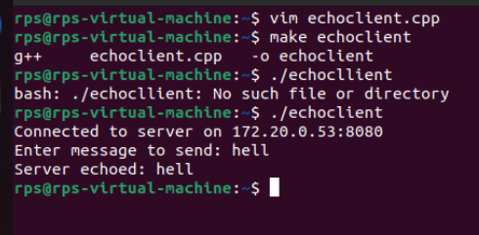

#include <iostream>

#include <cstring>

#include <unistd.h>

#include <arpa/inet.h>

#include <sys/socket.h>

using namespace std;

constexpr int PORT = 8080;

constexpr const char* SERVER_IP = "127.0.0.1"; // Use const char* instead of char*

constexpr int BUFFER_SIZE = 1024;

int main() {

int client_socket;

struct sockaddr_in server_addr;

char buffer[BUFFER_SIZE];

// Create socket

client_socket = socket(AF_INET, SOCK_STREAM, 0);

if (client_socket == -1) {

cerr << "Error creating socket\n";

return 1;

}

// Prepare the sockaddr_in structure

server_addr.sin_family = AF_INET;

server_addr.sin_port = htons(PORT);

inet_pton(AF_INET, SERVER_IP, &server_addr.sin_addr);

// Connect to server

if (connect(client_socket, (struct sockaddr *) &server_addr, sizeof(server_addr)) < 0) {

cerr << "Connection failed\n";

return 1;

}

cout << "Connected to server on " << SERVER_IP << ":" << PORT << "\n";

// Send message to server

cout << "Enter message to send: ";

cin.getline(buffer, BUFFER_SIZE);

send(client_socket, buffer, strlen(buffer), 0);

// Receive echoed message from server

int bytes_received = recv(client_socket, buffer, BUFFER_SIZE, 0);

if (bytes_received > 0) {

buffer[bytes_received] = '\0'; // Null-terminate received data

cout << "Server echoed: " << buffer << "\n";

}

close(client_socket);

return 0;

}